

**DATA STRUCTURES AND ALGORITHMS**

**PROJECT REPORT**

**BANK MANAGEMENT SYSTEM**

**SUBMITTED TO :**

**SIR SYED ALI NAQI RAZA**

**SUBMITTED BY:**

**GROUP MEMBERS**

**RABIA LATIF 20-SE-024**

**MUHAMMAD SADDIQUE 20-SE-010**

**AZAN HABIB 20-SE-034**

**DEPARTMENT OF SOFTWARE ENGINEERING**

**HITEC UNIVERSITY TAXILA CANTT**



PROJECT REPORT

BANK MANAGEMENT SYSTEM



**GROUP MEMBERS**

|  |  |
| --- | --- |
| NAME | REGISTRATION NUMBER |
| RABIA LATIF | **20-SE-024** |
| MUHAMMAD SADDIQUE | **20-SE-010** |
| AZAN HABIB | **20-SE-034** |

**TABLE OF CONTENTS**

**PROBLEM STATEMENT I**

**DECLARATION II**

**APPROVAL III**

**ACKNOWLEDGEMENTS IV**

**ABSTRACT V**

**MOTIVATION FOR CHOOSING THE PROJECT VI**

**CHAPTER 1**

1.1. Introduction

1.2. AIM of Project

1.3.Main Purpose

1.4.Features of BMS

1.5.Goals and Objectives

**CHAPTER 2**

2.1. DFD Diagram

2.2 sequence diagram

2.3 entity relation ship diagram

2.4 use case

**CHAPTER 3**

3.1 Description of Code

**CHAPTER 4**

4.1. Benefits

4.2. Conclusions

**REFRENCES**

**PROBLEM STATEMENT**

* Difference in accessing data
* Communication gap
* Updating problem
* Data inconsistency
* Data isolation
* Deleting data

**DECLARATION**

I Rabia Latif and my group members , declare that the project report entitled **“Bank Management System”** submitted to **Instructor Sir Syed Ali Naqi Raza** of **HITEC University** forconsideration of course **Data Structures And Algorithms**  in degree of Bachelor of Software Engineering (SE) embodies our own work with suggestion received during the work by some seniors and group members, which have been suitably acknowledged.

**APPROVAL**

We certify that this project **“Bank Management System”** is the original work of the above named candidates and has been doneunder supervision of group leader **Rabia Latif**. To the best of ourknowledge and belief, this work which embodies the work of candidates themselves, has been duly completed, fulfills the requirement of the final project of course **Data Structures and Algorithms** at **HITEC University** and is up to standard in respect of content, presentation and language for being referred to the instructor. The work has never been submitted anywhere. It’s only submitted to **Instructor Sir Syed Ali Naqi Raza** of **HITEC University**.

**PROJECT ADVISOR’S INFO:**

**SIR SYED ALI NAQI RAZA**

**LECTURER AND LAB INSTRUCTOR,**

**DEPARTMENT OF COMPUTER SCIENCE**

**HITEC UNIVERSITY**

**ACKNOWLEDGEMENTS**

We would like to express my deepest sense of gratitude to my reverend InstructorSir Syed Ali Naqi Raza, our course Lecturer and Lab Instructor, Department of Computer Science (CS), HITEC University, and, for his untiring guidance, constant supervision, enthusiasticencouragement, sagacious advice and an effective surveillance throughout the entire period of this course. We greatly say thank you. Wish toexpress my heart full thanks to all of my honorable teachers of the Department of ComputerScience (CS), HITEC University.

We sincerely thank HITEC University for giving me the chance aswell as the support for all the time being.

We also want to express appreciation to our classmates and seniors and friends who helped us in oneway or another during the course of developing this project. They endured the long hours ofmy absence during the development of this project.

We deeply express respect to our parents and teachers for their blessing and constant inspiration in every step of my education. We are very thankful to all of our friends for their help and company during the work and for giving us the encouragement to carry out the work.

Finally, we express gratitude to the Almighty Allah, the most beneficent & the most merciful, for granting us the opportunity to write this intern project report.

**May ,2021**

Rabia Latif (20-SE024)&

M.Saddique(20-SE-010)&

Azan Habib(20-SE-034)

**Dept. of Software Engineering**

**HITEC University**

**ABSTRACT**

The Bank Management System is an application for maintaining a person's account in a bank. In this project we tried to show the working of a banking system and cover the basic functionality of a Bank Management System. To develop a project for solving financial applications of a customer in banking environment in order to nurture the needs of an end banking user by providing various ways to perform banking tasks. Also to enable the user’s workspace to have additional functionalities which are not provided under a conventional banking project.

The Bank Management System undertaken as a project is based on relevant technologies. The main aim of this project is to develop software for Bank Account Management System. This project has been developed to carry out the processes easily and quickly, which is not possible with the manuals systems, which are overcome by this software. This project is developed using C++ language. The content management system deals with data entry, validation confirm and updating whiles the interactive system deals with system interaction with the administration and users. Thus, features of this project will save transaction time and therefore increase the efficiency of the system.

**MOTIVATION FOR CHOOSING THE PROJECT**

Motivation behind choosing the project is banking system in real , which offers different functionalities like creating account, deleting account , account enquiry, deposit and withdraw money, checking account, etc. Bank management system allows user to perform all of the above functionalities. It is essential to keep record of bank accounts of users.



**INTRODUCTION AND PROJECT DETAILS INFORMATION**

**1.1. Introduction**

**1.2. AIM of Project**

**1.3. Main Purpose**

**1.4. Features of BMS**

**1.5. Goals and Objectives**

* 1. **INTRODUCTION**

The “Bank Management System” project is a model Banking system. This enables the customers to perform the basic banking transactions. The system provides the access to the customer to create anaccount, deposit/withdraw the cash from his account, also to view reports of all accountspresent. The customers can access the banks for viewing their account details andperform the transactions on account as per their requirements. The primary aim of this “Bank Management System” is to provide an improved design methodology, which envisages the future expansion, and modification, which isnecessary for a core sector like banking. This necessitates the design to be expandable andmodifiable and so a modular approach is used in developing the application software.Anybody who is an Account holder in this bank can become a member of Bank Account Management System. He has to fill a form with his personal details and Account Number.

Bank is the place where customers feel the sense of safety for their property. In the bank,customers deposit and withdraw their money. Transaction of money also is a part wherecustomer takes shelter of the bank. Now to keep the belief and trust of customers, there is thepositive need for management of the bank, which can handle all this with comfort and ease.Smooth and efficient management affects the satisfaction of the customers and staffmembers, indirectly. And of course, it encourages management committee in taking someneeded decision for future enhancement of the bank.Now a day’s, managing a bank is tedious job up to certain limit. So software that reduces thework is essential. Also today’s world is a genuine computer world and is getting faster andfaster day-by-day. Thus, considering above necessities, the software for bank management

has became necessary which would be useful in managing the bank more efficiently.

The program has been developed using the C++ language using concepts of linked list ,sorting,searching, classes, objects, structures,etc.

* 1. **AIM OF PROJECT**

The main aim of developing this Bank Management System is primarily based on project of course DAA STRUCTURES AND ALGORITHMS in Software Engineering. Customer will have all options and features in this program like create account, show account, delete account, withdraw or deposit money, update account.

* 1. **MAIN PURPOSE**

The project gives real life understanding of Banking System and activities performed by various roles in the supply chain. Here, we provide automation for banking system . Bank Management System projectcaptures activities performed by different roles in real life banking which provides enhanced techniques for maintaining the required information up-to-date, which results in efficiency.

* 1. **FEATURES OF BMS**
* Creating new accounts: Multiple new accounts can be created
* Displaying customer’s details : Will display details of account whose Id will be chose by user
* Checking account details: Inquiry of account details
* Deposit money : Customer can easily deposit money in account
* Withdraw money : Withdraw money from account
* Delete account :Delete an existing
* Updating Information in an existing account: Update or change information of account
  1. **GOALS AND OBJECTIVES**

Our motto is to develop a program for managing the entire bank process and to keep each every track about customer’s property and their various transaction processesefficiently.

**\*\*\*\*\*\*\*\*\*\*\*\*\*\*\*\*\***

**CHAPTER 2**

**DESIGN AND DIAGRAMS**

**2.1 DFD Diagram**

**2.2 SEQUENCE DIAGRAM**

**2.3 ENTITY RELATION SHIP DIAGRAM**

**2.4 USE CASE**

**2.1. DATA FLOW DIAGRAM**

**DATA FLOW DAIGRAM FOR CREATING ACCOUNT**

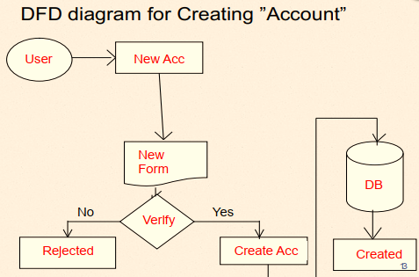

FIGURE: DATA FLOW DAIGRAM FOR CREATING ACCOUNT

**DATA FLOW DIAGRAM FOR TRANSACTIONS**

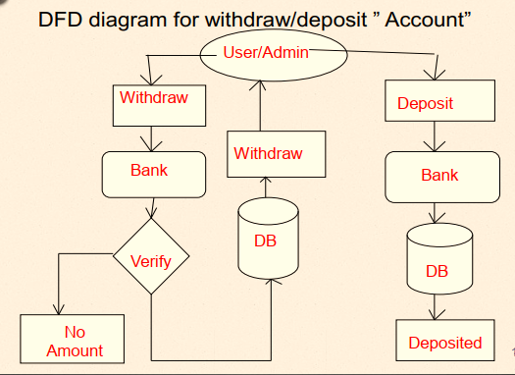

FIGURE:DATA FLOW DAIGRAM FOR TRANSACTIONS

**DATA FLOW DAIGRAM FOR DELETING ACCOUNT**

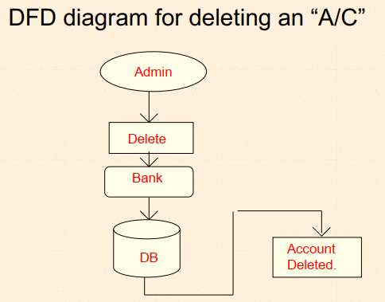

FIGURE: DATA FLOW DAIGRAM FOR DELETING ACCOUNT

**SEQUENCE DIAGRAM FOR BANK MANAGEMNT SYSTEM**

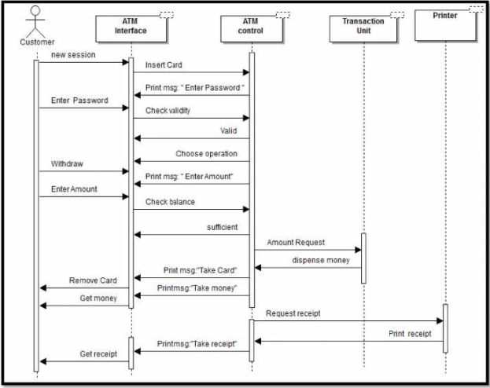

FIGURE:SEQUENCE DIAGRAM FOR BANK MANAGEMNT SYSTEM

**ENTITY RELATIONSHIP DIAGRAM FOR BANK MANAGEMNT SYSTEM**

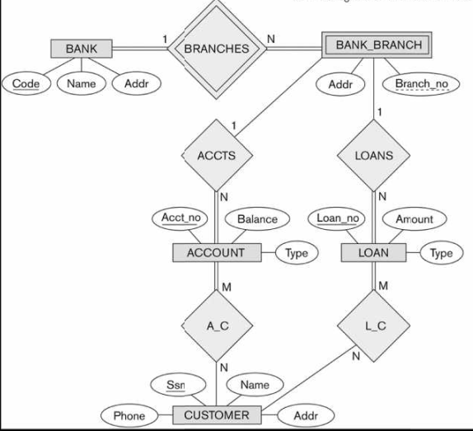

**FIGURE:ENTITY RELATIONSHIP DIAGRAM**

**USE CASE DIAGRAM FOR BANK MANAGEMNT SYSTEM**

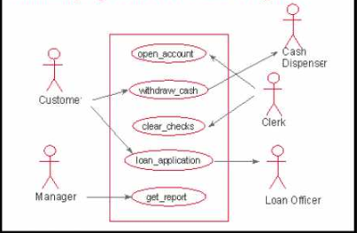

**USE CASE DIAGRAM**

********************

**CHAPTER 3**

**\*\*\*\*\*\*\*\*\*\*\*\*\*\*\*\*\*\*\*\*\***

**DETAILS**

**3.1. DESCRIPTION OF CODE**

**3.1. DESCRIPTION OF CODE**

This C++ code has been made using concepts of Object Oriented Programming,programming fundamentals and mainly data structures and algorithms .

**Header files**

* **#include <iostream>**
* **#include <fstream>:**for file handling
* **#include <windows.h>:** for background(5) color and text(E) color
* #**include<conio.h>:** for getch() and cls
* #**include <string.h>:** for functions

In this code, we have used the concepts of:

* Linked list
* Classes
* Objects
* Structures
* Loops
* If-else statements
* Switch statements
* Arithmetic operators
* Logical operators
* Comparison operators, etc.

**Language Used: C++**

**Tool used: Dev C++**

functionsare:

* options
* Insert_record
* Delete_record
* Deposit
* Withdraw
* Search _record
* Show_record
* modify

**Function options**: Has 1-7 options in which user will choose any option of choice and perform that specific task.

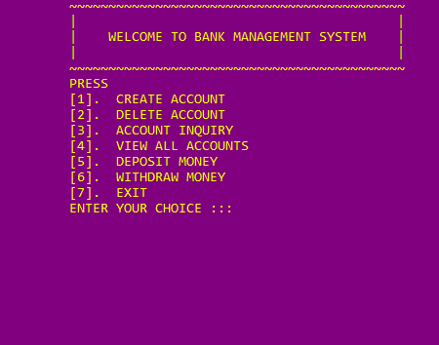

**Function insert record**: In this ,function user /customer will first choose that how many accounts he/she will create and after that add his information and then confirms that he has input the right information if right information is being added then user need to press given specific number and then proceeds further .And if ,wrong information is added the user need to repeat the procedure.

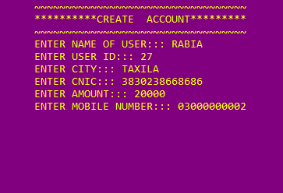

**Function view_details**: In this, function ADMIN checks information of existing accounts.

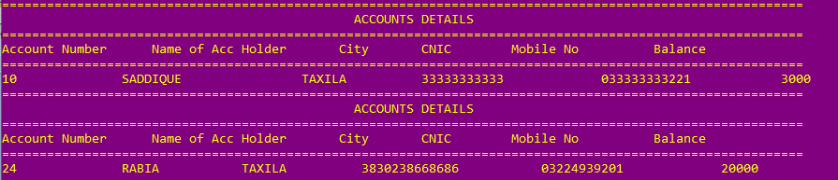

**Function search**: In this function, any account holder can inquire his account.

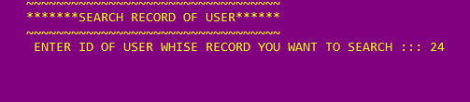

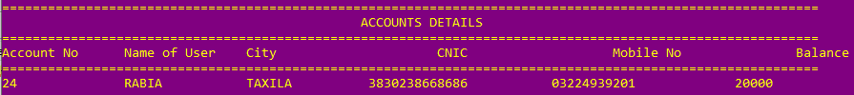

**Function transaction**: In this function, user can either withdraw or deposit money from account.

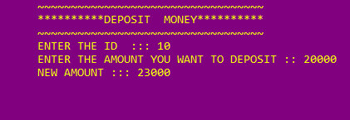

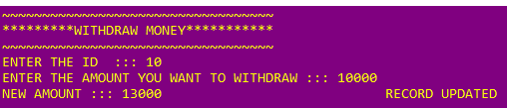

**Function delete record**: In this function, user account can be deleted.

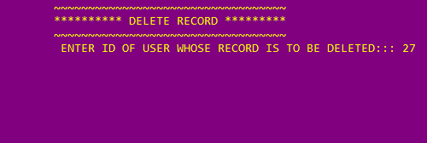 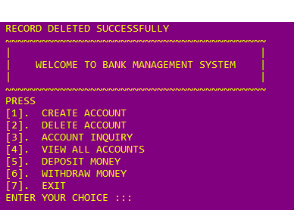

**\*\*\*\*\*\*\*\*\*\*\*\*\*\*\*\*\***

**CHAPTER 5**

**SUMMARY**

**5.1. BENEFITS**

**5.2. CONCLUSIONS**

**5.1. BENEFITS**

Some of the benefits of Bank Management System are:

* Provide flexibility
* For better performance.
* Reducing man power.
* For doing work more accurately.
* Faster performance.

**5.2. CONCLUSIONS**

* **This banking system is made by using concepts of oop and dsa**
* **We successfully implemented the concepts of:** 
  1. **Linked list**
  2. **Searching**
  3. **sorting**
* **Thus the Bank Management System it is developed and executed successfully.**

**\*\*\*\*\*\*\*\*\*\*\*\*\*\*\*\*\*\*\*\*\*\*\***

**REFRENCES**

* [**https://www.scribd.com/presentation/410773396/Bank-Management-System**](https://www.scribd.com/presentation/410773396/Bank-Management-System)
* [**http://www.w3schools.comm**](http://www.w3schools.comm)
* [**http://www.slideshare.net**](http://www.slideshare.net)
* [**http://www.freebanglatutorial.com**](http://www.freebanglatutorial.com)
* [**http://www.youtube.com**](http://www.youtube.com)

**\*\*\*\*\*\*\*\*\*\*\*\*\*\*\*\*\*\*\*\*\*\*\***